Paddy Crop Disease Detection using Ann, CNN & Resnet101

In this project we are implementing 3 different deep learning algorithms such as ANN, CNN and ResNet101 to predict paddy diseases such as Healthy, Leaf Black, Brown Spot or Hispa.

To implement this project we have downloaded Paddy Doctor dataset from KAGGLE which consists of more than 5000 images and below screen showing dataset details

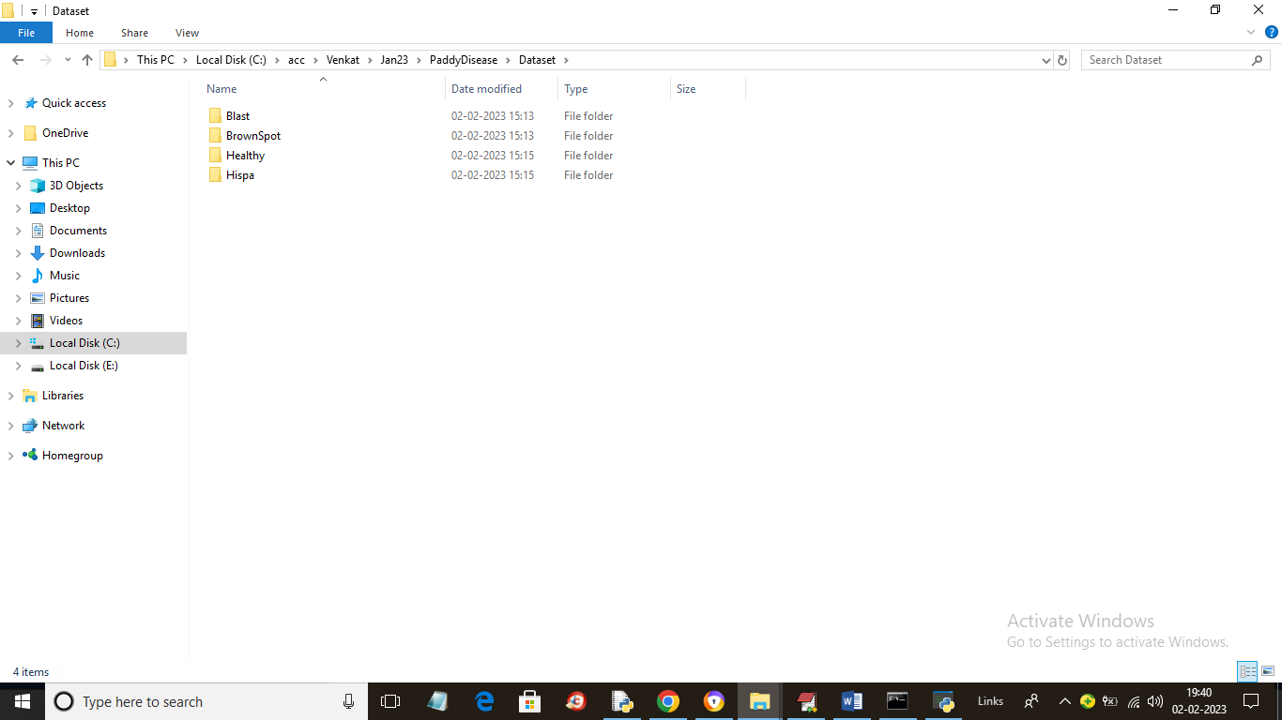

In above screen we have 4 folders inside dataset folder and just go inside any folder to view images like below screen

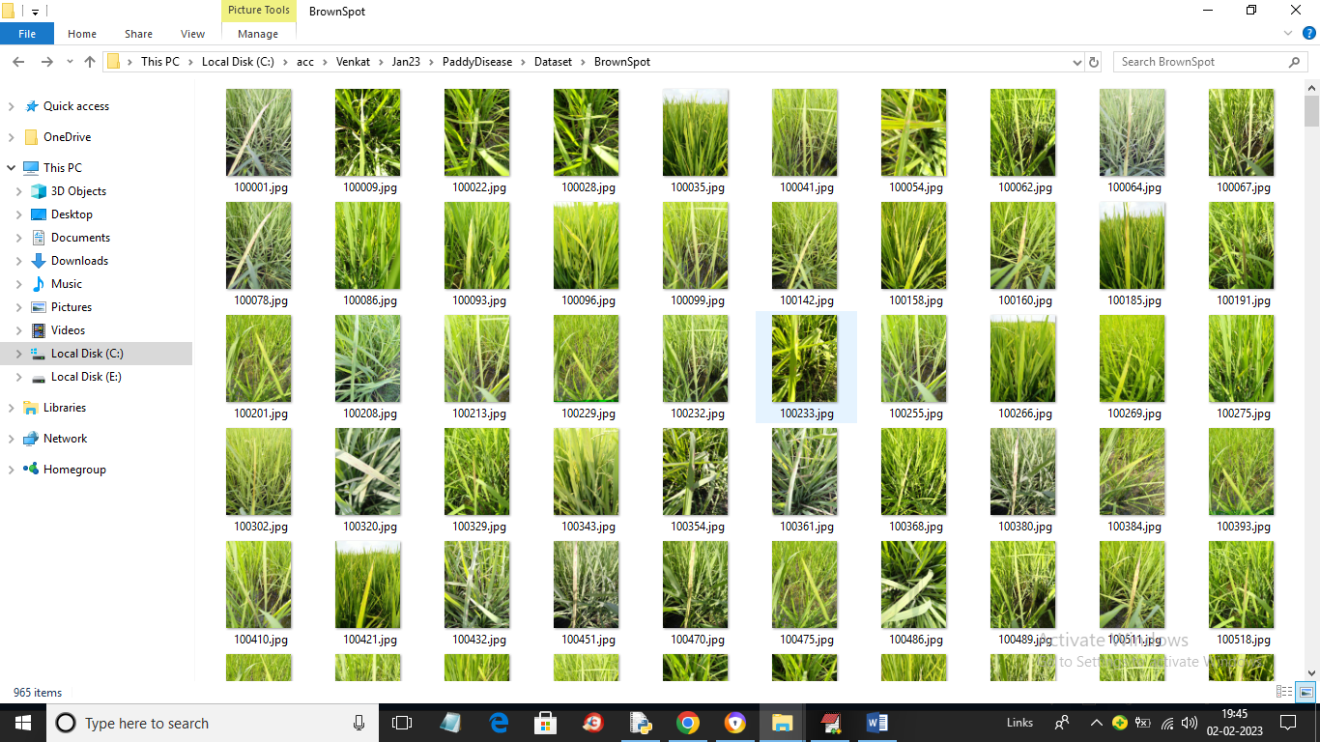

In above screen we can see paddy images and by using above images we will train and evaluate performance of all algorithms

To implement this project we have designed following modules

1. Upload Paddy Disease Dataset: using this module we will upload entire dataset folder to application and then will read all images and plot graph of various diseases found in dataset
2. Preprocess Dataset: using this module we will read all images and then normalize pixel values, shuffle dataset images and split dataset into train and test where application using 80% dataset images for training and 20% for testing
3. Run ANN Algorithm: using this module we will input 80% images to ANN algorithm to trained a model and this trained model will be applied on 20% test images to calculate prediction accuracy
4. Run CNN Algorithm: using this module we will input 80% images to CNN algorithm to trained a model and this trained model will be applied on 20% test images to calculate prediction accuracy
5. Run Resnet Algorithm: using this module we will input 80% images to Resnet algorithm to trained a model and this trained model will be applied on 20% test images to calculate prediction accuracy
6. Comparison Graph: using this module we will plot accuracy comparison graph between all algorithms
7. Predict Disease from Test Image: using this module we will upload test image and then Resnet will identify image is paddy leaf or not and if paddy leaf then it will predict disease.

SCREEN SHOTS

To run project double click on ‘run.bat’ file to get below screen

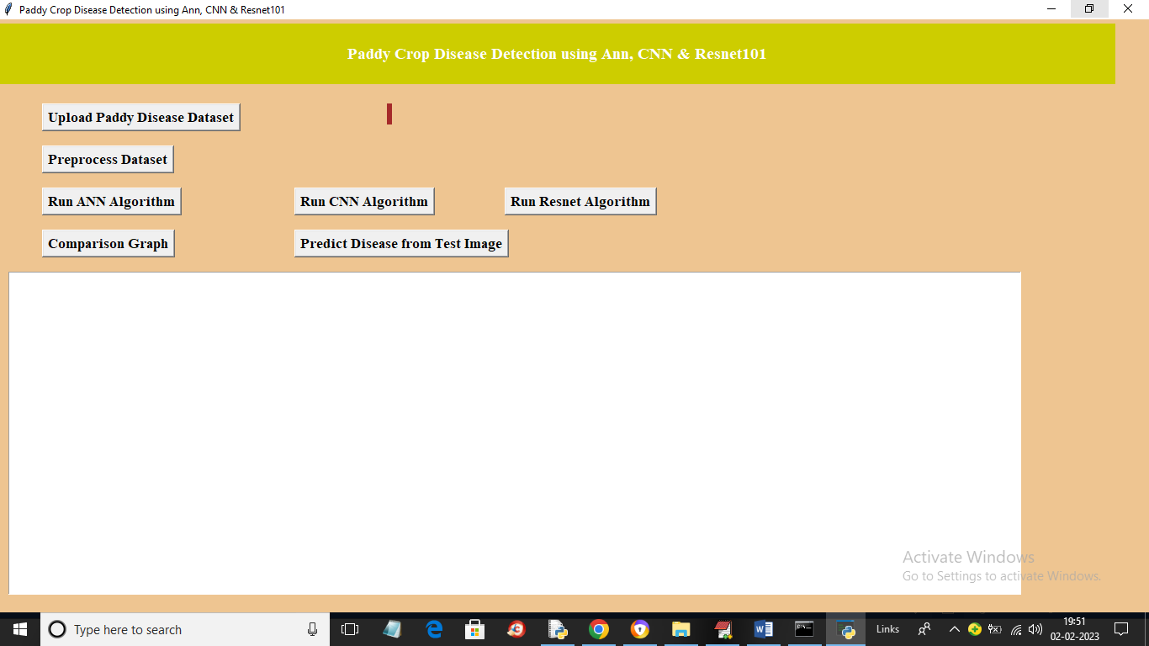

In above screen click on ‘Upload Paddy Disease Dataset’ button to upload dataset images and get below output

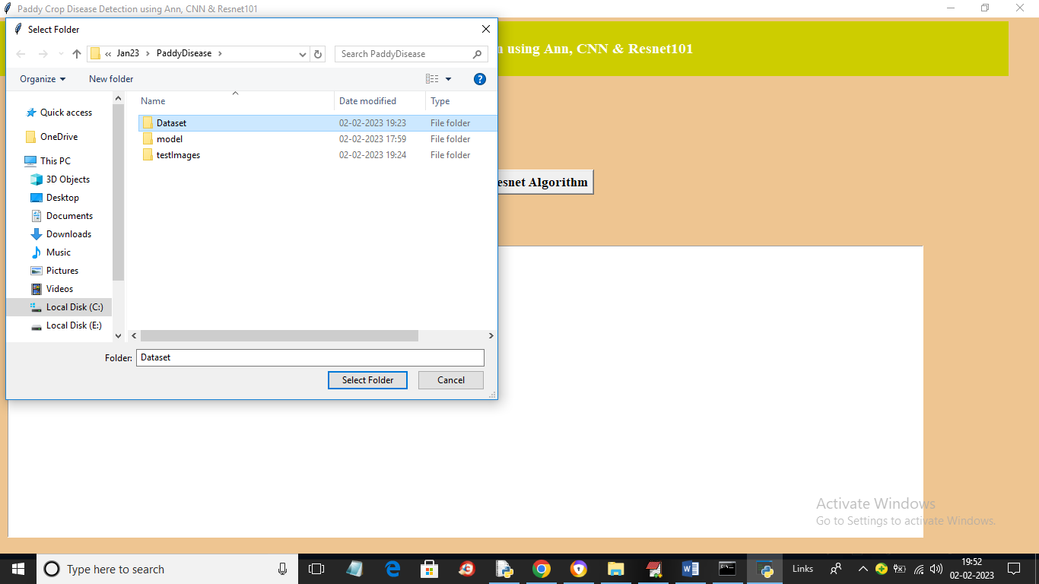

In above screen selecting and uploading entire dataset folder and then click on ‘Dataset’ button to load dataset and get below output

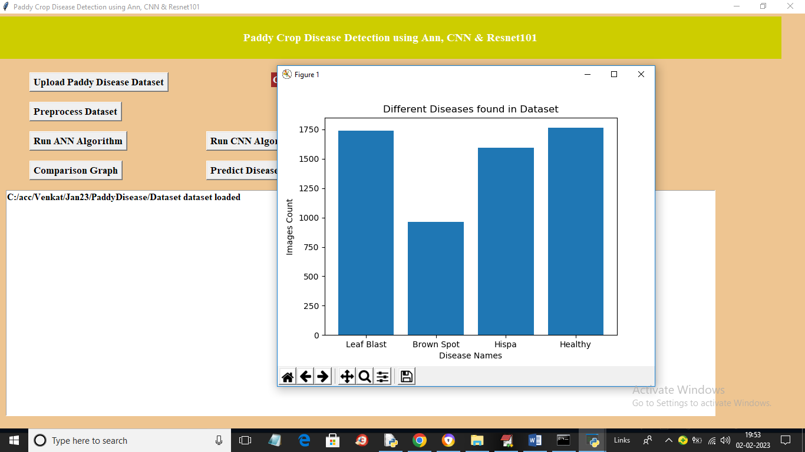

In above screen dataset loaded and in graph x-axis represents paddy disease and y-axis represents number of images found for that disease in dataset and now close above image and then click on ‘Preprocess Dataset’ button to process images and get below output

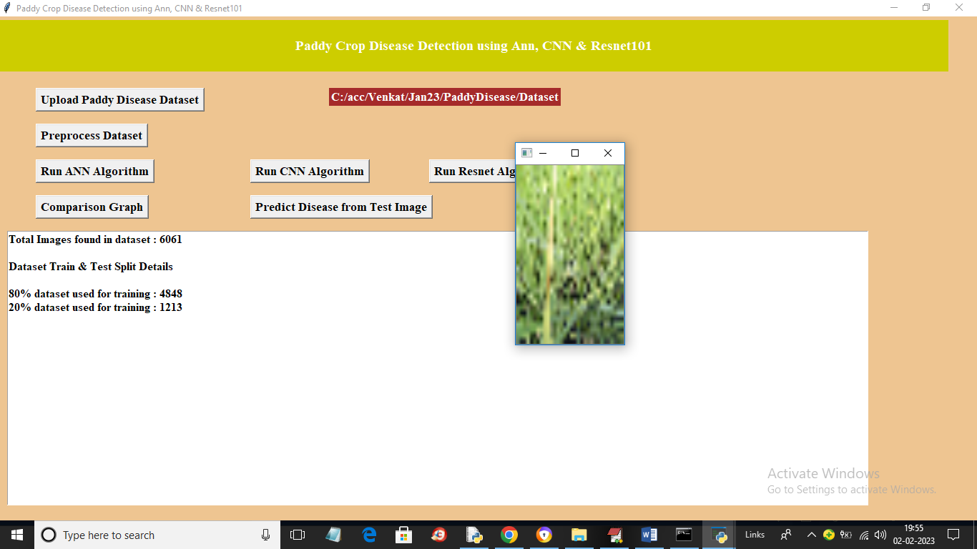

In above screen we can see dataset contains 6061 images and application using 80% (4848) images for training and 20% (1213) images for testing and we can see sample processed image also and now close that image and dataset is ready and now click on ‘Run ANN Algorithm’ button to train ANN and get below output

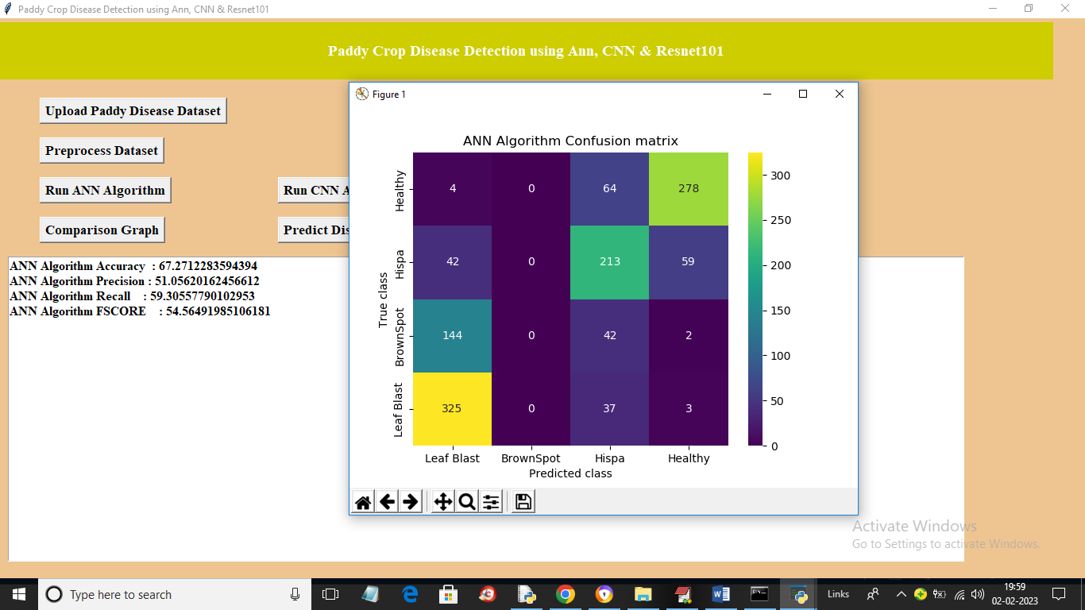

In above screen with ANN we got 67% accuracy and we can see other metrics also like precision, recall and FSCORE and in confusion matrix graph x-axis represents Predicted Labels and Y-axis represents True Labels and all boxes in diagnol represents correct prediction count and remaining boxes contains incorrect prediction count. In above graph we can see there so many boxes with incorrect prediction count so ANN is not accurate and now close above graph and then click on ‘Run CNN Algorithm’ button to get below graph

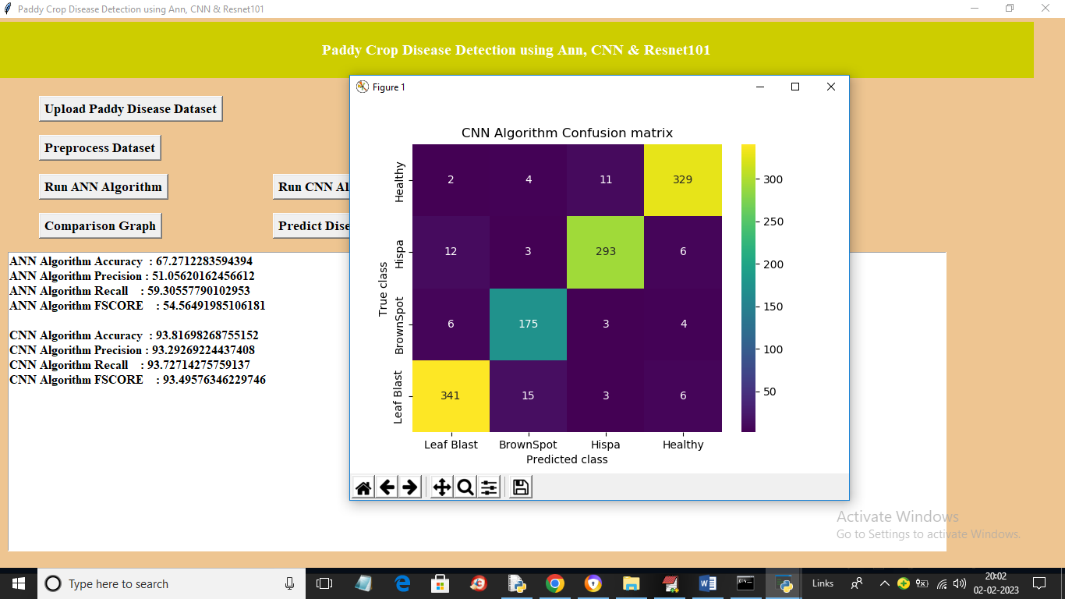

In above screen with CNN we got 93% accuracy and in confusion matrix graph different colour boxes in diagnol contains correct prediction count and same blue colour boxes contains incorrect prediction count. In above graph we can see only few incorrect counts in blue boxes so we can say CNN is little good in performance. Now close above graph and then click on ‘Run Resnet Algorithm’ button to get below output

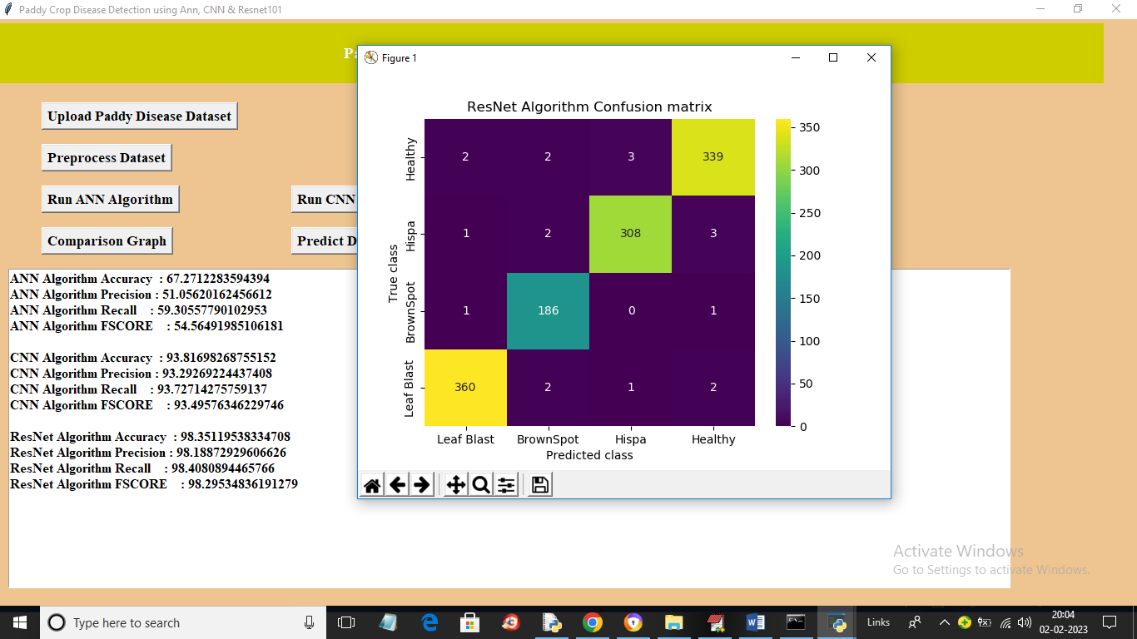

In above screen with Resnet we got 98% accuracy and in blue boxes only 2 or 3 images are incorrectly predicted and in diagonal different colour boxes we can see more number of images are correctly predicted. Now click on ‘Comparison Graph’ button to get below graph

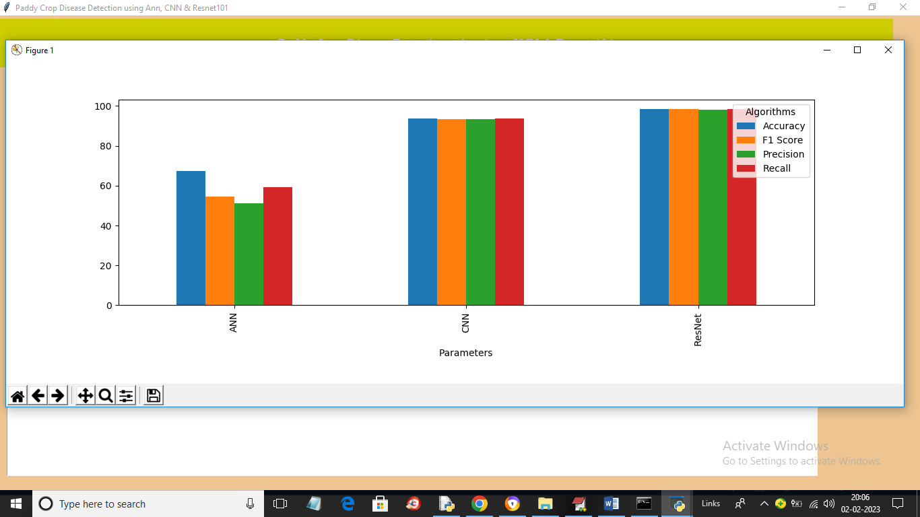

In above graph x-axis represents algorithm names and y-axis represents accuracy and other metrics in different colour bars and in all algorithms RESNET got high accuracy and now close above graph and then click on ‘Predict Disease from Test Image’ button to upload test image and get prediction output

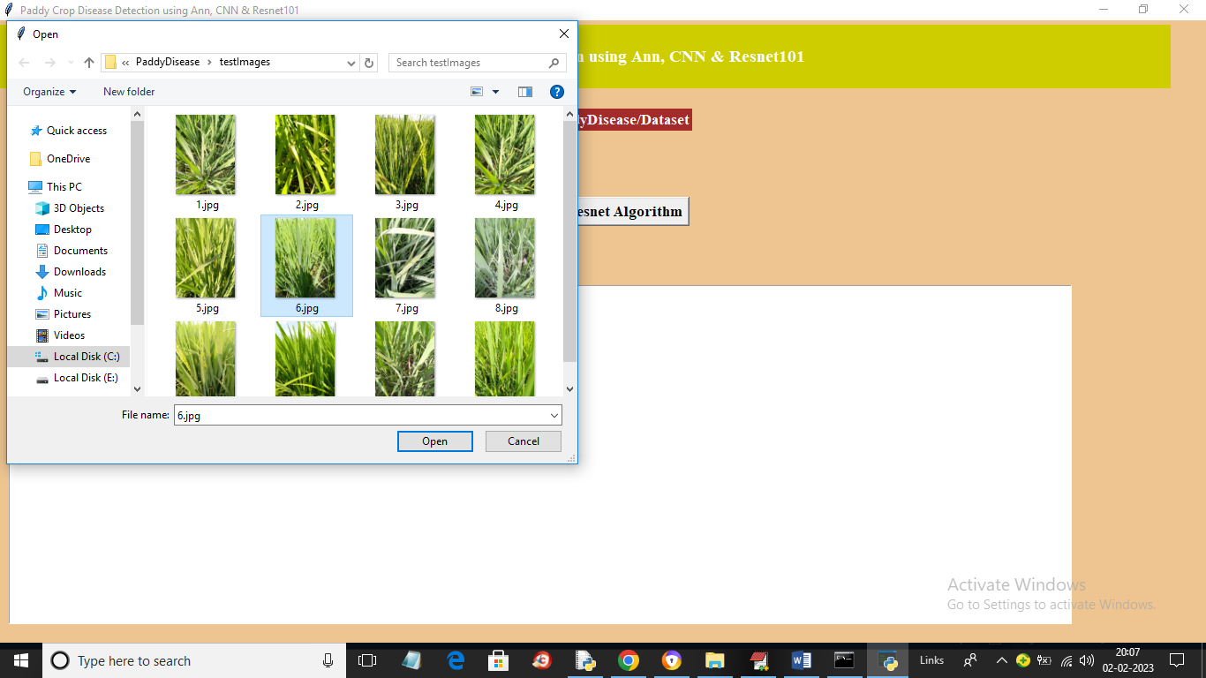

In above screen selecting and uploading test image and then click on ‘Open’ button to get below output

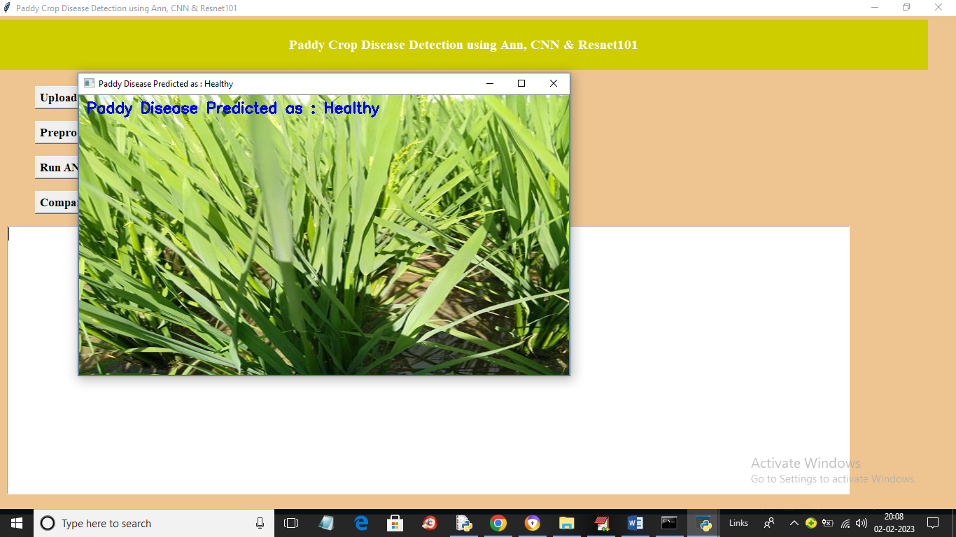

In above screen image is predicted as Healthy and similarly you can upload and test other images

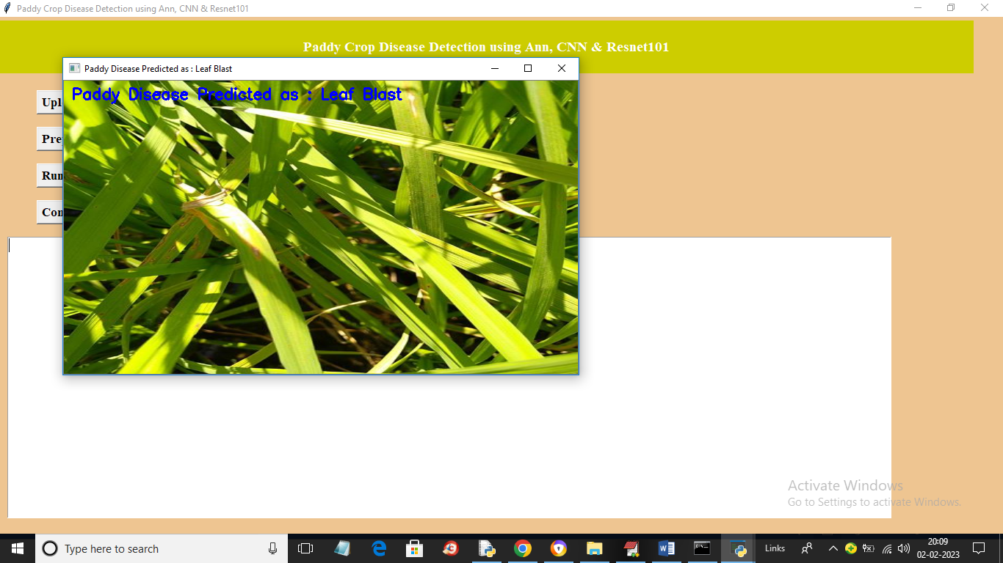

Above image is leaf blast

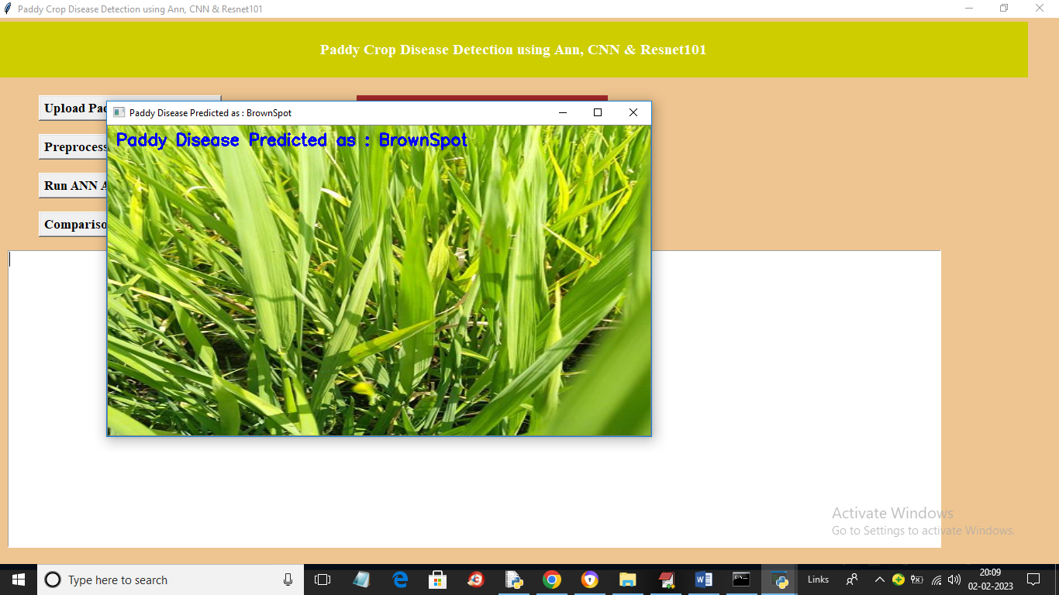

Above image is brown spot

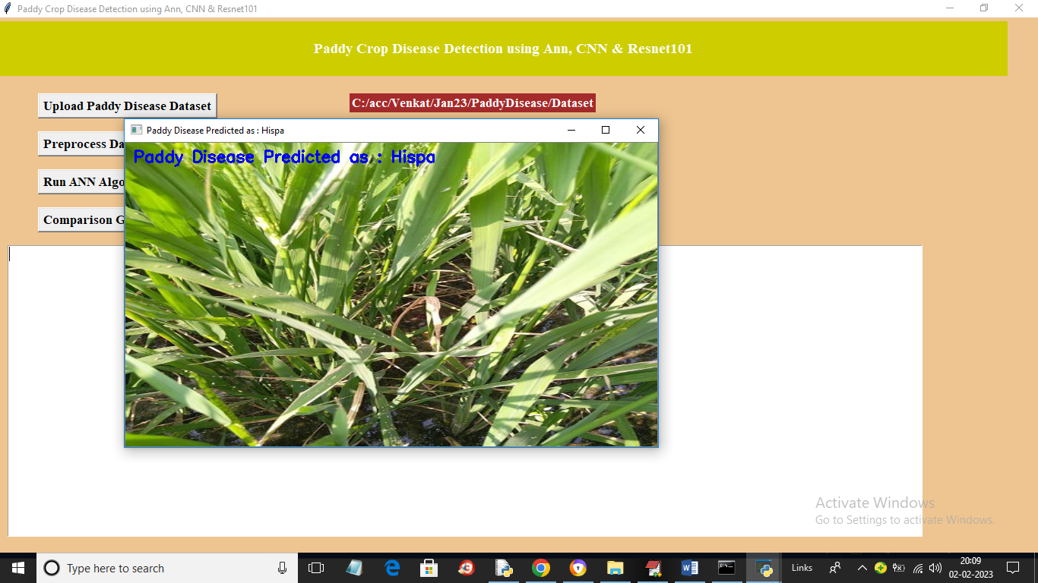

Above image predicted as Hispa and if we upload other images then will get below output

